Raport roczny

Samorządów Studenckich Uczelni Vistula

2025/2026



Spis treści

Samorząd AfiB 4
Samorząd SGTiH 17

Samorząd AfiB

Raport Roczny

2025/2026



STUDENT COUNCIL AFIB
Name of activity / Nazwa aktywności: | WORKEIN Company Workshop
Date of the event / Data wydarzenia: | 18.12.2025
What have you been doing / Co Państwo robiliście na wydarzeniu: | We hosted workshop about residence legalization processes and obtaining TRC process
Budget / Budżet | 0
How many people attend / Ile było uczestników: | 20
What problems did you have / Jaki mieliście problemy: | We had a problem with the Aula media system, microphones were buzzing
Add the photo / Dodaj zdjęcie
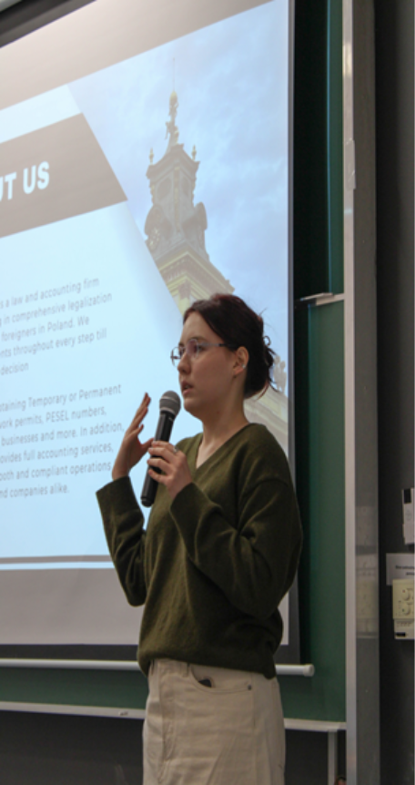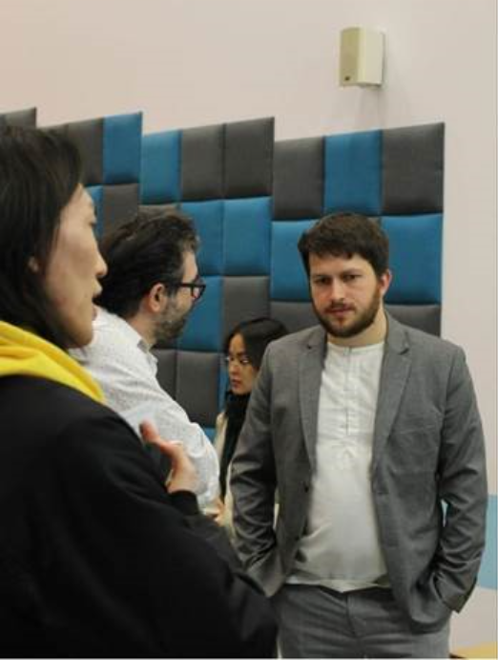

STUDENT COUNCIL AFIB
Name of activity / Nazwa aktywności: | Christmas Art Workshop
Date of the event / Data wydarzenia: | 16.12.2025
What have you been doing / Co Państwo robiliście na wydarzeniu: | We were doing decorations for christmass event
Budget / Budżet | 146 zl
How many people attend / Ile było uczestników: | 15
What problems did you have / Jaki mieliście problemy: | We had a problem with connecting to the Aula media system, lack of materials that leads to lack of hand-made style decorations for the Christmas Event
Add the photo / Dodaj zdjęcie:
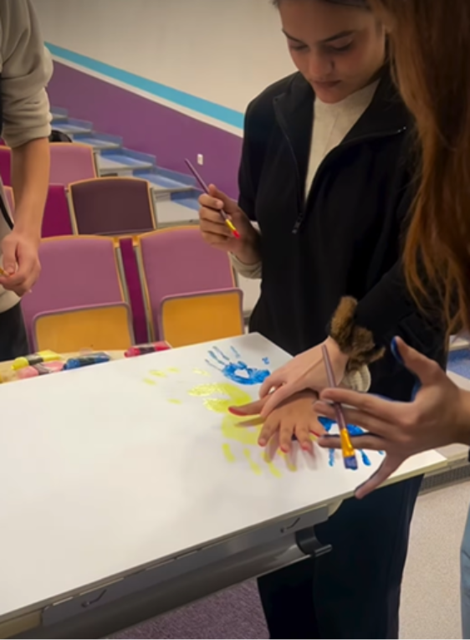

STUDENT COUNCIL AFIB
Name of activity / Nazwa aktywności: | Xmas concert
Date of the event / Data wydarzenia: | 19.12.2025
What have you been doing / Co Państwo robiliście na wydarzeniu: | We prepared video showed during event, decorations and helped to clean aula after event
Budget / Budżet | 0
How many people attend / Ile było uczestników: | 200
What problems did you have / Jaki mieliście problemy: | x
Add the photo / Dodaj zdjęcie:
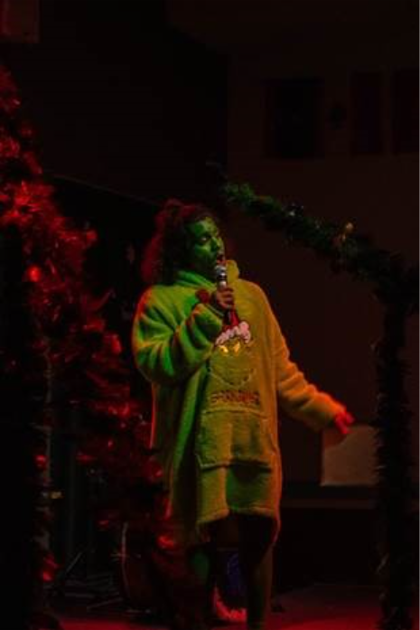
STUDENT COUNCIL AFIB
Name of activity / Nazwa aktywności: | Workein-TRC workshops
Date of the event / Data wydarzenia: | 09.03.2026
What have you been doing / Co Państwo robiliście na wydarzeniu: | We hosted 2nd part workshops about residence legalization processes and obtaining TRC process
Budget / Budżet | 0
How many people attend / Ile było uczestników: | 25
What problems did you have / Jaki mieliście problemy: | x
Add the photo / Dodaj zdjęcie:
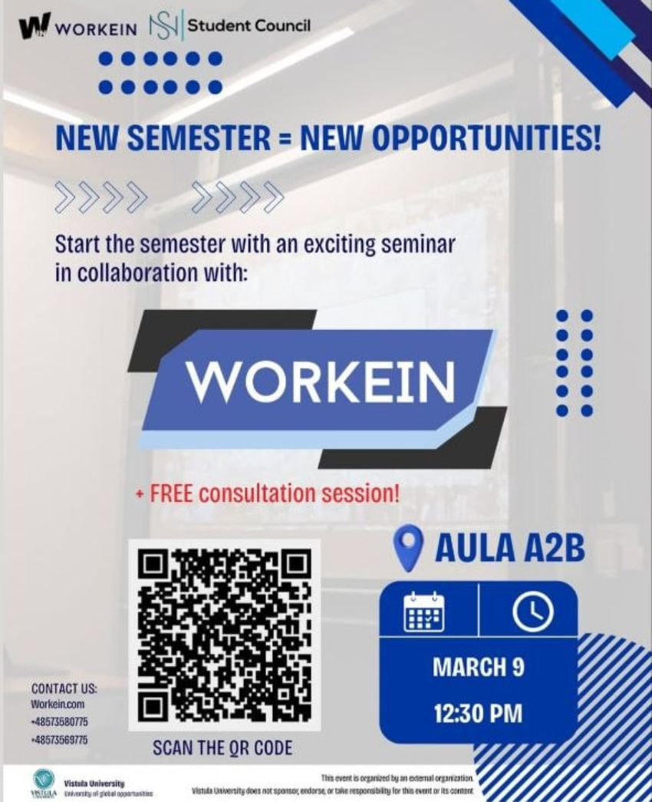
STUDENT COUNCIL AFIB
Name of activity / Nazwa aktywności: | Free legal consultation with Workein company
Date of the event / Data wydarzenia: | 12.03.2026
What have you been doing / Co Państwo robiliście na wydarzeniu: | Following 2nd part of workshops we made helpdesk where professional lawyer was giving free legal consultations to our students
Budget / Budżet | 0
How many people attend / Ile było uczestników: | 30
What problems did you have / Jaki mieliście problemy: | x
Add the photo / Dodaj zdjęcie:
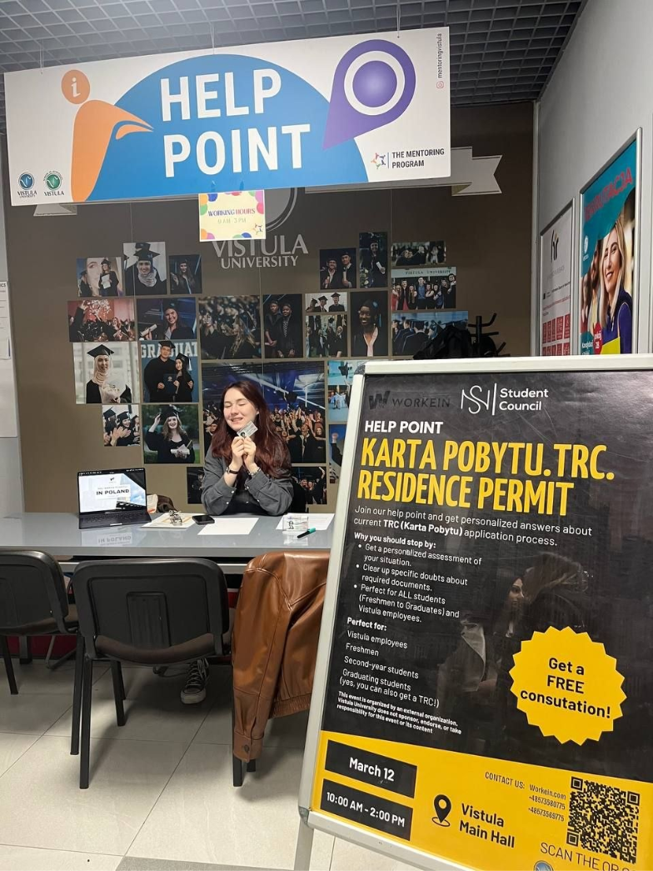
STUDENT COUNCIL AFIB
Name of activity / Nazwa aktywności: | Tokenization
Date of the event / Data wydarzenia: | 12
What have you been doing / Co Państwo robiliście na wydarzeniu: | Folls
Budget / Budżet | 0
How many people attend / Ile było uczestników: | 30
What problems did you have / Jaki mieliście problemy: | x
Add the photo / Dodaj zdjęcie:

STUDENT COUNCIL AFIB
Name of activity / Nazwa aktywności:
Date of the event / Data wydarzenia: | 12.03.2026
What have you been doing / Co Państwo robiliście na wydarzeniu: | Following 2nd part of workshops we made helpdesk where professional lawyer was giving free legal consultations to our students
Budget / Budżet | 0
How many people attend / Ile było uczestników: | 30
What problems did you have / Jaki mieliście problemy: | x
Add the photo / Dodaj zdjęcie:

STUDENT COUNCIL AFIB
Name of activity / Nazwa aktywności: | National Conference of the Student Parliament of the Republic of Poland
Date of the event / Data wydarzenia: | 23-26. 04.2026
What have you been doing / Co Państwo robiliście na wydarzeniu: | Representation of Student Council consisting of Olaf Bojko and Bartłomiej Dwórnik attended congress of Student Parliament of the Republic of Poland held in Kościelisko, delegation attended multiple workshops, learning session, they also integrated with other student councils, discussed issues of our university with others and shared knowelage and possible solutions how to improve student’s life at campus
Budget / Budżet | 2900
How many people attend / Ile było uczestników: | +100
What problems did you have / Jaki mieliście problemy: | During trip Bartłomiej Dwórnik offended Minister of Science and Higher Education and acting arrogantly and showing no remorse when parliament president tried to address his behavior. This caused serious image issue to our student council and leaded to series of other problems including internal conflict in council and excluding us from cooperations on mutual inter-universities events.
Add the photo / Dodaj zdjęcie:

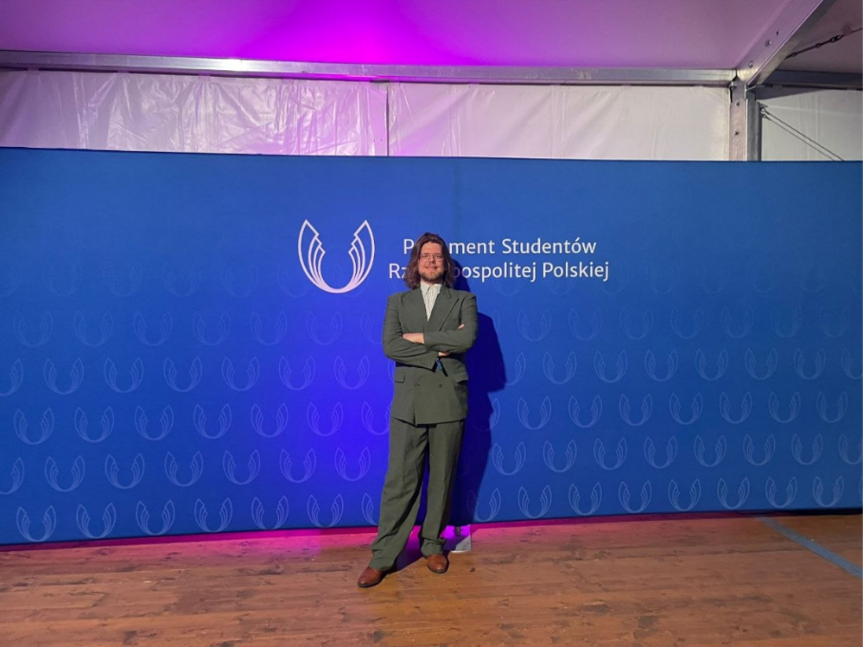
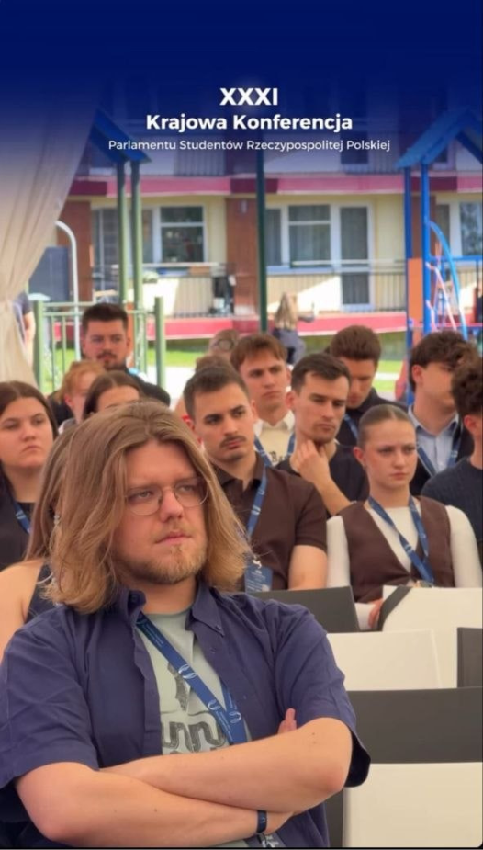

STUDENT COUNCIL AFIB
Name of activity / Nazwa aktywności: | Congress of Private Universities Forum
Date of the event / Data wydarzenia: | 04-07. 06.2026
What have you been doing / Co Państwo robiliście na wydarzeniu: | Representation of Student Council consisting of Olaf Bojko and Dmytro Yarmoliuk attended cogress of Private Universities Forum in Poronin. Delegates started from explaining currect situation in our council and explained the unauthorized actions and slandering student council carried out by Bartłomiej Dwórnik, which were the aftermath of his scandal at the PSRP congress. Delegation took action to fix relations and our image and they successed, after that we were invited back to work with others on mutual events and futhure collaborations. Except that, delegates took part in value and useful workshops and discussion sessions, Olaf also took part in voting as representative of Council’s President.
Budget / Budżet | 2400
How many people attend / Ile było uczestników: | +50
What problems did you have / Jaki mieliście problemy: | x

STUDENT COUNCIL AFIB
Name of activity / Nazwa aktywności: | Smash Party 2.0
Date of the event / Data wydarzenia: | 14.06.2026
What have you been doing / Co Państwo robiliście na wydarzeniu: | Following talk of our delegation at Congress of Private Universities Forum, we were invited to cooperate and co organize grill party together with sevral other universities, collaboration included promoting party on social media, providing volunteers for work at place.
Budget / Budżet | 0
How many people attend / Ile było uczestników: | +250
What problems did you have / Jaki mieliście problemy: | Through our earlier exclusion from activities with other universities due to Bartłomiej Dwórnik's scandal from PSRP congess and later actions we joined collaboration very late and haven’t managed to become official partners of the event, because of that our logo lacked on official promo materials and we couldnt

Samorząd SGTiH

Raport Roczny

2025/2026



Name of activity / Nazwa aktywności:
  Spring Culture Fest
Date of the event / Data wydarzenia:
  Spring Semester
What have you been doing / Co Państwo robiliście na wydarzeniu:
  Student Council STiH actively participated in organizing and supporting the Spring Culture Fest. Our team prepared and arranged decorations for the photo zone to make the space more attractive and comfortable for students. We also organized a competition for the best national dish, encouraging students to share their cultures and traditions through food. During the festival, our members worked as volunteers, helping with event organization, assisting participants, and supporting the smooth flow of activities.
Budget / Budżet
  100 PLN (trophy cup for the winner of the best national dish competition)
How many people attend / Ile było uczestników:
  Not specified
What problems did you have / Jaki mieliście problemy:
  No problems reported
