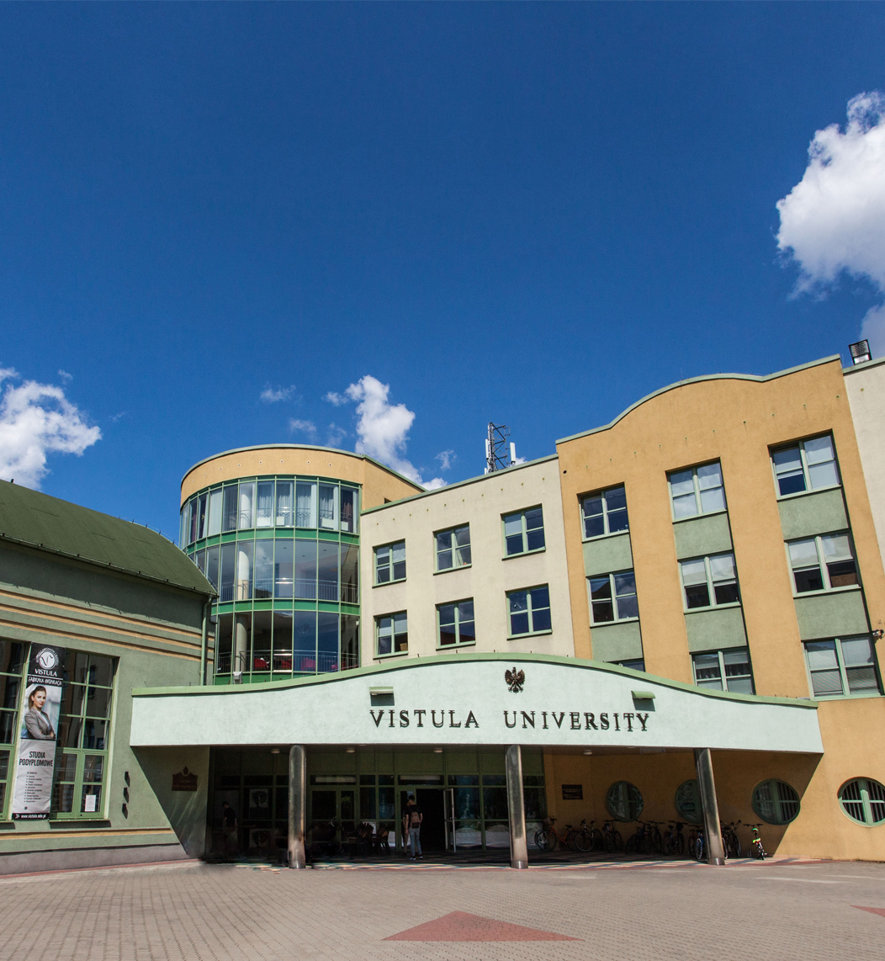

**Doctoral Seminar   
discipline   
Management and Quality Sciences**

**Name of the seminar:**

**Doctoral seminar in the discipline of Management and Quality Studies**

Field of science: Social sciences

Discipline: Management and Quality Studies.

Form of study: Hybrid

Classes will be held every two weeks of each month in accordance with the Vistula Academic Calendar.

Number of semesters: 6

Language: English.

**Head of the Study Programme:**

Prof. Shahriyar Mukhtarov (PhD) – Professor of the Faculty of Business and International Relations, Vistula University.

email address: s.mukhtarov@vistula.edu.pl

phone no.: [+48 22 457 23](tel:+48%2022%2045%2072%20401) 69

**Contact details:**

Postgraduate Studies and Training Center,Vistula University.

email address: [phd@vistula.edu.pl](mailto:phd@vistula.edu.pl)

phone no.:[+48 22 457 23 63](tel:+48%2022%2045%2072%20401)

**Purpose of the Seminar**

Our 6-semester Doctoral Seminar is addressed to graduates of Master's degree programmes (regardless of the completed field of study) who wish to obtain a doctoral degree in the discipline of Management and Quality Studies.

**The aim of the Seminar** is to prepare its participants for independent research work and to provide scientific supervision during the preparation of a doctoral dissertation.

Seminar participants will have the opportunity to:

* Become familiar with the methodology of scientific work as well as the methodology of preparing scientific texts, including doctoral dissertations.
* Acquire theoretical knowledge and practical skills necessary to plan and conduct scientific research, in particular to formulate research questions and hypotheses and apply research methods and techniques.
* Develop skills in the field of working with scientific literature, obtaining and processing data, conducting scientific research, developing and documenting scientific texts.
* Developing the concept and writing a doctoral dissertation under scientific supervision.

**The advantages of the Doctoral Seminar** offered by Vistula University include:

* Participation in classes aimed at improving scientific skills necessary to prepare a doctoral dissertation.
* Individual consultations with scientific supervisors enabling students to develop a concept and then write a doctoral dissertation.
* Facilitating publication of a scientific article, which is a necessary condition for obtaining a doctoral degree.
* Acquire learning outcomes corresponding to level 8 of the Polish Qualifications Framework.
* Possibility to participate in the life of Vistula University scientific community.

The seminar is intended to help all candidates who wish to involve in scientific work and independently acquire knowledge necessary for the preparation of a research project leading to obtaining a doctoral degree in the discipline of Management and Quality Studies.

Our program focuses on issues related to proper formulation of research questions and hypotheses/theses, as well as to adapting appropriate research methods to the selected research questions.

Practical exercises will allow you to acquire the skills necessary to plan and implement your own research project.

**Framework program of the Doctoral Seminar**

* Legal and ethical bases of research in the social sciences (8th level of Qualifications framework)
* Copyright and intellectual property protection (8th level of Qualifications framework)
* Research Methods in Management
* Advanced Topics in Management I
* Quantitative research methods
* Qualitative research methods
* Trends in the Development of Modern Civilization (8th level of Qualifications framework)
* Theoretical foundations and paradigms of science (8th level of Qualifications framework)
* Statistical methods in the social sciences
* Advanced Topics in Management II
* Techniques for writing and publishing scientific articles
* Contemporary technologies in Management
* Doctoral seminars
* Individual consultations with scientific supervisors
* Applied Econometrics: Time-Series Data Analysis
* Contemporary Major Management Issues
* Introduction to academic teaching
* Data Science

**Framework program of 6-semester doctoral seminars at Vistula University in Warsaw in the field of social sciences, discipline of** **Management and Quality Studies in the academic year 2025 / 2026.**

*Classes will be held every two weeks of each month in accordance with the Vistula Academic Calendar.*

|  |  |  |  |  |  |  |
| --- | --- | --- | --- | --- | --- | --- |
| **Nu.** | | **Name of the course** | Nu. of hours | | Effect from the Polish qualifications framework, level 8th | Verification of achievement of 8PRK effects |
|  | | **Semestr 1** |  | |  |  |
|  | |  |  | |  |  |
| 1. | | Legal and ethical bases of research activities and higher education | 4 | | P8S_ WK  P8S_KO | E I |
| 2. | | Research Methods in Management | 6 | | P8S_ WG | P+ E II |
| 3. | | Copyright and intellectual property protection | 2 | | P8S_KR | P+ E I |
| 4. | | Advanced Topics in Management I | 18 | | P8S_ WG | E II +DD |
|  | | **Total hours** | **[30]** | | **--------** |  |
|  | | **Semestr 2** |  | | ------- |  |
| 5. | | Quantitative research methods | 6 | | P8S_UW | DD+ P |
| 6. | | Qualitative research methods | 6 | | P8S_UW | DD+ P |
| 7. | | Statistical methods in the social sciences | 14 | | P8S_UW | DD+ P |
| 8. | | Trends in the Development of Modern Civilization | 4 | | P8S_ WK | E I |
|  | | **Total hours** | **[30]** | | **-----** |  |
|  | | **Semestr 3** |  | | ---------- |  |
| 9. | | Advanced Topics in Management II | 16 | |  | E II |
| 10. | | Techniques for writing and publishing scientific articles | 4 | | P8S_UK  P8S-KR | DD+ P |
| 11. | | Contemporary technologies in Management | 6 | | P8Z-WZ | E I +E II |
| 12. | | Theoretical foundations and paradigms of science | | 4 | P8Z_WT | | E I |
|  | | **Total hours** | | **[30]** | **---------** | |  |
|  | | **Semestr 4** | |  | -------- | |  |
| 13. | | Applied Econometrics: Time-Series Data Analysis | | 16 | P8Z-WO | | DD+ P |
| 14. | | Introduction to academic teaching | | 4 | P8S_UK  P8S_UU | | E I |
| 15. | | Contemporary Major Management Issues | | 10 | P8S_WG | | E II |
|  | | **Total hours** | | **[30]** | **------** | |  |
|  | | **Semestr 5** | |  | ------ | |  |
| 16. | | Doctoral seminar | | 8 | P8S_UK P8S_KK | | DD+P |
| 17. | | Individual consultations | | 6 | P8Z_UI  P8S_UO | | DD+P |
| 18. | | Data Science | | 16 | P8Z-WO | | E II+ P |
|  | | **Total hours** | | **[30]** | **-------** | |  |
|  | | **Semestr 6** | |  | ------ | |  |
| 19. | | Doctoral seminar | | 15 | P8S_UK  P8S_KK | | DD+P |
| 20. | | Individual consultations | | 15 | P8Z_UI  P8S_UO | | DD+P |
|  | | **Total hours** | | **[30]** | **------** | |  |
|  | | **Total number of contact hours** | |  |  | |  |

This program has been developed in accordance with: Polish Qualifications Framework level 8, Requirements contained in Art. 186 of the Law on Higher Education of July 20, 2018 (as amended).

**Lectures are held in:** English

**Verification of achievement of 8PRK effects:**

* Exam I (oral exam) in the field of achieving the 8PRK results. (Conducted by the Committee of the Scientific Council of the Discipline)- E I
* Examination II (oral examination) in the discipline of Management and Quality Sciences. (Carried Committee of the Scientific Council of the Discipline Committee)-E II
* Submitted scientific publications (Verification in the publishing procedure) – P
* Doctoral dissertation (Verification by the supervisor, reviewers and during public defense)- DD

Obtaining learning outcomes at level 8 of the Polish Qualifications Framework is fully confirmed by a doctoral diploma in the discipline of Management and Quality Sciences issued by Vistula University.

**Description of educational subjects:**

**1. Legal and ethical bases of research activities and higher education.**

Classes introducing legal regulations in the field of science and higher education, enabling doctoral students to function in an academic environment in accordance with applicable standards.

**2. Research Methods in Management and Quality Sciences.**

Research Methods in Management and Quality Sciences" equips candidates with the essential tools and techniques for rigorous quantitative and qualitative analysis. This course covers different approaches to critically analyze social phenomena, fostering skills in hypothesis testing, causal inference, and policy evaluation.

**3. Copyright and intellectual property protection.**

Preparation for practical application of current regulations on the protection of intellectual property in scientific and teaching activities.

**4. Advanced Topics in Management.**

It delves into complex and contemporary issues in management theory, providing candidates with a deep understanding of cutting-edge research and emerging debates. The course typically covers topics preparing candidates to contribute to scholarly discourse.

**5. Quantitative research methods.**

This introduces quantitative approaches for understanding complex social. This course covers methods like questionnaire interviews, emphasizing data collection and analysis techniques that provide, contextual insights based on numerical data.

**6. Qualitative research methods.**

It introduces non-quantitative approaches for understanding complex social. This course covers methods like interviews, case studies emphasizing data collection and analysis techniques that provide rich, contextual insights beyond numerical data.

**7. Statistical methods in the social sciences.**

This provides candidates with essential tools for analyzing and interpreting data in social research. The course covers topics like probability theory, hypothesis testing, and regression analysis, enabling students to apply statistical techniques to investigate patterns and relationships within social phenomena.

**8. Trends in the Development of Modern Civilization**

Showing general concepts and trends regarding the development of modern civilization, allowing for a broader perspective in the field of social sciences.

**9. Advanced Topics in Management**

This course elves into complex theories management of organizations. The course covers areas like project management, human capital management, preparing candidates to engage with cutting-edge research and address sophisticated social and organizational challenges.

**10. Techniques for writing and publishing scientific articles.**

Teaching doctoral students in the field of practice publications in their discipline and providing them with tools to facilitate their own activities publication. In particular, PhD students become familiar with the basic principles submitting research results for publication and reviewing scientific articles; The most important bibliometric indicators and their role will also be discussed.

**11. Contemporary technologies in Management**.

This provides computational techniques for analyzing large datasets and extracting predictive insights relevant management. The course covers algorithms such as regression, classification, and clustering, emphasizing applications for economic modeling, financial forecasting, and data-driven decision-making.

**12. Theoretical foundations and paradigms of science.**

Implementation of the skills of practical application of general, dominant paradigms and theories of scientific cognition.

**13. Applied Econometrics: Time-Series Data Analysis.**

It focuses on econometric techniques for analyzing data that evolves over time, which is essential in field of management.

**14. Introduction to academic teaching.**

Classes aimed at expanding doctoral students' knowledge and skills in the field planning pedagogical work, analyzing and assessing the course of educational processes, and determining and assessing their effects. Issues related to: regularities and conditions of the teaching-learning process.

**15. Contemporary Major Management Issues**

This course examines current challenges and trends shaping global economies. This course covers topics such as economic and social crises, policy responses, globalization, and sustainable management, equipping students with the analytical tools to understand and critically assess these pressing issues.

**16. Data Science.**

This course explores rigorous analytical techniques, computational methods, and advanced statistical tools to tackle complex research questions. Through hands-on projects and interdisciplinary collaboration, doctoral candidates gain the expertise needed to transform raw data into actionable insights that drive impactful discoveries in their fields.

**17. Doctoral seminar.**

During classes in a group and in a form, skills necessary to implement a research project in the discipline of Management are developed.

**18. Individual consultations.**

The classes are aimed at improving the skills necessary for effective management research related to the subject of the doctoral dissertation. They are strictly in nature individualized, taking into account what is important both from the point of view of the doctoral student and from the point of view of the promoter, the issue of scientific workshop.

**Fees:**

Application fee – **100 Euro one-time**

Tuition fee – **3000 Euro per year**

Payment to the bank account of Vistula University in Warsaw, ul. Stokłosy 3:

Bank: BANK OCHRONY ŚRODOWISKA S.A.

Adres: ul. Żelazna 32, 00-832 Warszawa

Kod Swift: EBOSPLPWXXX

IBAN: PL  
Nr konta: 47 1540 1030 2103 0003 7384 0006