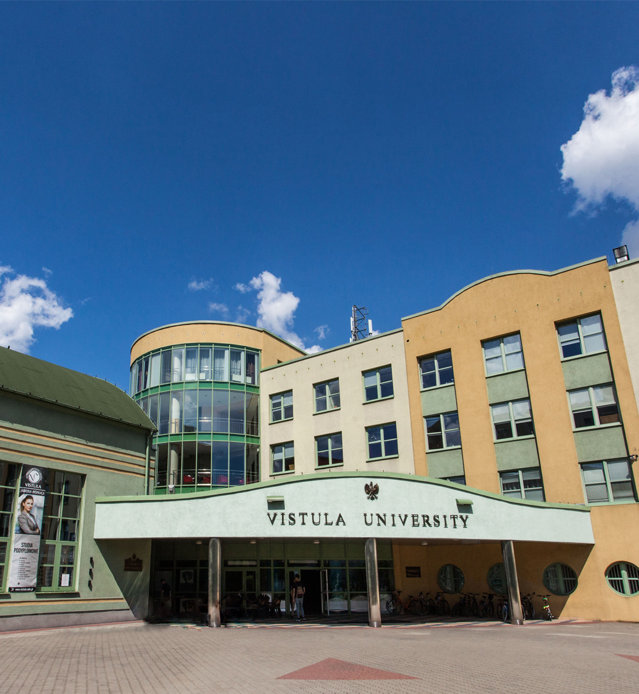

**Doctoral seminar in the discipline of Economics and Finance**

**Name of the seminar:**

**Doctoral seminar in the discipline of Economics and Finance**

Field of science: Social sciences

Discipline: Economics and Finance.

Form of study: Hybrid

Classes will be held every two weeks of each month in accordance with the Vistula Academic Calendar.

Number of semesters: 6

Language: English.

**Head of the Study Programme:**

Prof. Shahriyar Mukhtarov (PhD) – Professor of the Faculty of Business and International Relations, Vistula University.

email address: s.mukhtarov@vistula.edu.pl

phone no.: [+48 22 457 23](tel:+48%2022%2045%2072%20401) 69

**Contact details:**

Postgraduate Studies and Training Center,Vistula University.

email address: [phd@vistula.edu.pl](mailto:phd@vistula.edu.pl)

phone no.:[+48 22 457 23 63](tel:+48%2022%2045%2072%20401)

**Purpose of the Seminar**

Our 6-semester Doctoral Seminar is addressed to graduates of Master's degree programmes (regardless of the completed field of study) who wish to obtain a doctoral degree in the discipline of Economics and Finance.

In 2020, changes were implemented as regards the methods of obtaining a doctoral degree. Doctoral studies were replaced by doctoral schools. Candidates who wish to obtain a doctoral degree but who at the same time do not want or cannot give up their professional careers still have an open path to obtaining this academic degree through the procedure of applying for a **doctoral degree on an extramural basis**. The seminar offered at our University can be regarded as the first stage of this path.

**The aim of the Seminar** is to prepare its participants for independent research work and to provide scientific supervision during the preparation of a doctoral dissertation.

Seminar participants will have the opportunity to:

* Become familiar with the methodology of scientific work as well as the methodology of preparing scientific texts, including doctoral dissertations.
* Acquire theoretical knowledge and practical skills necessary to plan and conduct scientific research, in particular to formulate research questions and hypotheses and apply research methods and techniques.
* Develop skills in the field of working with scientific literature, obtaining and processing data, conducting scientific research, developing and documenting scientific texts.
* Developing the concept and writing a doctoral dissertation under scientific supervision.

**The advantages of the Doctoral Seminar** offered by Vistula University include:

* Participation in classes aimed at improving scientific skills necessary to prepare a doctoral dissertation.
* Individual consultations with scientific supervisors enabling students to develop a concept and then write a doctoral dissertation.
* Facilitating publication of a scientific article, which is a necessary condition for obtaining a doctoral degree.
* Acquire learning outcomes corresponding to level 8 of the Polish Qualifications Framework.
* Possibility to participate in the life of Vistula University scientific community.

The seminar is intended to help all candidates who wish to involve in scientific work and independently acquire knowledge necessary for the preparation of a research project leading to obtaining a doctoral degree in the discipline of Economics and Finance.

Our program focuses on issues related to proper formulation of research questions and hypotheses/theses, as well as to adapting appropriate research methods to the selected research questions.

Practical exercises will allow you to acquire the skills necessary to plan and implement your own research project.

**Framework program of the Doctoral Seminar**

* Legal and ethical bases of research in the social sciences (8th level of Qualifications framework)
* Copyright and intellectual property protection (8th level of Qualifications framework)
* Research Methods in Economics and Finance
* Advanced Topics in Economics
* Quantitative research methods
* Qualitative research methods
* Trends in the Development of Modern Civilization (8th level of Qualifications framework)
* Theoretical foundations and paradigms of science (8th level of Qualifications framework)
* Statistical methods in the social sciences
* Advanced Topics in Finance
* Techniques for writing and publishing scientific articles
* Doctoral seminars
* Individual consultations with scientific supervisors
* Machine Learning for Economists and Financiers
* Applied Econometrics: Time-Series Data Analysis
* Contemporary Major Economic and Financial Issues
* Introduction to academic teaching
* Applied Econometrics: Panel Data Analysis

**Framework program of 6-semester doctoral seminars at Vistula University in Warsaw in the field of social sciences, discipline of Economics and Finance.**

*Classes will be held every two weeks of each month in accordance with the Vistula Academic Calendar.*

|  |  |  |  |  |
| --- | --- | --- | --- | --- |
| **Nu.** | **Name of the course** | Nu. of hours | Effect from the Polish qualifications framework, level 8th | Verification of achievement of 8PRK effects |
|  | **Semestr 1** |  |  |  |
| 1. | Legal and ethical bases of research activities and higher education | 4 | P8S_ WK  P8S_KO | E I |
| 2. | Research Methods in Economics and Finance | 6 | P8S_ WG | P+ E II |
| 3. | Copyright and intellectual property protection | 2 | P8S_KR | P+ E I |
| 4. | Advanced Topics in Economics | 18 | P8S_ WG | E II +DD |
|  | **Total hours** | **[30]** | **--------** |  |
|  | **Semestr 2** |  | ------- |  |
| 5. | Quantitative research methods | 6 | P8S_UW | DD+ P |
| 6. | Qualitative research methods | 6 | P8S_UW | DD+ P |
| 7. | Statistical methods in the social sciences | 14 | P8S_UW | DD+ P |
| 8. | Trends in the Development of Modern Civilization | 4 | P8S_ WK | E I |
|  | **Total hours** | **[30]** | **-----** |  |
|  | **Semestr 3** |  | ---------- |  |
| 9. | Advanced Topics in Finance | 16 |  | E II |
| 10. | Techniques for writing and publishing scientific articles | 4 | P8S_UK  P8S-KR | DD+ P |
| 11. | Machine Learning for Economists and Financiers | 6 | P8Z-WZ | E I +E II |
| 12. | Theoretical foundations and paradigms of science | 4 | P8Z_WT | E I |
|  | **Total hours** | **[30]** | **---------** |  |
|  | **Semestr 4** |  | -------- |  |
| 13. | Applied Econometrics: Time-Series Data Analysis | 16 | P8Z-WO | DD+ P |
| 14. | Introduction to academic teaching | 4 | P8S_UK  P8S_UU | E I |
| 15. | Contemporary Major Economic and Financial Issues | 10 | P8S_WG | E II |
|  | **Total hours** | **[30]** | **------** |  |
|  | **Semestr 5** |  | ------ |  |
| 16. | Doctoral seminar | 8 | P8S_UK P8S_KK | DD+P |
| 17. | Individual consultations | 6 | P8Z_UI  P8S_UO | DD+P |
| 18. | Applied Econometrics: Panel Data Analysis | 16 | P8Z-WO | E II+ P |
|  | **Total hours** | **[30]** | **-------** |  |
|  | **Semestr 6** |  | ------ |  |
| 19. | Doctoral seminar | 15 | P8S_UK  P8S_KK | DD+P |
| 20. | Individual consultations | 15 | P8Z_UI  P8S_UO | DD+P |
|  | **Total hours** | **[30]** | **------** |  |
|  | **Total number of contact hours** |  |  |  |

This program has been developed in accordance with: Polish Qualifications Framework level 8, Requirements contained in Art. 186 of the Law on Higher Education of July 20, 2018 (as amended).

**Lectures are held in:** English

**Verification of achievement of 8PRK effects:**

* Exam I (oral exam) in the field of achieving the 8PRK results. (Conducted by the Committee of the Scientific Council of the Discipline)- E I
* Examination II (oral examination) in the discipline of economics and finance. (Carried Committee of the Scientific Council of the Discipline Committee)-E II
* Submitted scientific publications (Verification in the publishing procedure) – P
* Doctoral dissertation (Verification by the supervisor, reviewers and during public defense)- DD

Obtaining learning outcomes at level 8 of the Polish Qualifications Framework is fully confirmed by a doctoral diploma in the discipline of economics and finance issued by Vistula University.

**Description of subjects:**

1. **Legal and ethical bases of research activities and higher education.**

Classes introducing legal regulations in the field of science and higher education, enabling doctoral students to function in an academic environment in accordance with applicable standards.

1. **Research Methods in Economics and Finance.**

Research Methods in Economics and Finance" equips candidates with the essential tools and techniques for rigorous quantitative and qualitative analysis. This course covers different approaches to critically analyze economic and financial phenomena, fostering skills in hypothesis testing, causal inference, and policy evaluation.

1. **Copyright and intellectual property protection**.

Preparation for practical application of current regulations on the protection of intellectual property in scientific and teaching activities.

1. **Advanced Topics in Economics.**

It delves into complex and contemporary issues in economic theory and applied economics, providing candidates with a deep understanding of cutting-edge research and emerging debates. The course typically covers topics such as advanced macroeconomics and microeconomic theory, preparing candidates to contribute to scholarly discourse.

1. **Qualitative research methods.**

It introduces non-quantitative approaches for understanding complex social and economic phenomena. This course covers methods like interviews, case studies, and ethnography, emphasizing data collection and analysis techniques that provide rich, contextual insights beyond numerical data.

1. **Statistical methods in the social sciences.**

This provides candidates with essential tools for analyzing and interpreting data in social research. The course covers topics like probability theory, hypothesis testing, and regression analysis, enabling students to apply statistical techniques to investigate patterns and relationships within social phenomena.

1. **Trends in the Development of Modern Civilization**

Showing general concepts and trends regarding the development of modern civilization, allowing for a broader perspective in the field of social sciences.

1. **Advanced Topics in Finance**

This course elves into complex financial theories and contemporary issues, equipping candidates with an in-depth understanding of advanced finance concepts. This course covers areas like asset pricing, risk management, and financial markets, preparing candidates to engage with cutting-edge research and address sophisticated financial challenges.

1. **Techniques for writing and publishing scientific articles.**

Teaching doctoral students in the field of practice publications in their discipline and providing them with tools to facilitate their own activities publication. In particular, PhD students become familiar with the basic principles submitting research results for publication and reviewing scientific articles; The most important bibliometric indicators and their role will also be discussed.

1. **Machine Learning for Economists and Financiers**

This provides computational techniques for analyzing large datasets and extracting predictive insights relevant to economics and finance. The course covers algorithms such as regression, classification, and clustering, emphasizing applications for economic modeling, financial forecasting, and data-driven decision-making.

1. **Theoretical foundations and paradigms of science**

Implementation of the skills of practical application of general, dominant paradigms and theories of scientific cognition.

1. **Applied Econometrics: Time-Series Data Analysis**

It focuses on econometric techniques for analyzing data that evolves over time, which is essential in fields like economics and finance.

13. **Introduction to academic teaching**

Classes aimed at expanding doctoral students' knowledge and skills in the field planning pedagogical work, analyzing and assessing the course of educational processes, and determining and assessing their effects. Issues related to: regularities and conditions of the teaching-learning process.

1. **Contemporary Major Economic and Financial Issues**

This course examines current challenges and trends shaping global economies and financial markets. This course covers topics such as economic crises, policy responses, globalization, and sustainable finance, equipping students with the analytical tools to understand and critically assess these pressing issues.

1. **Applied Econometrics: Panel Data Analysis.**

It focuses on econometric methods for analyzing data that includes multiple observations over time for the same entities, such as individuals, firms, or countries. This course covers techniques like fixed effects, random effects, and dynamic panel models, allowing candidates to address issues of causality, heterogeneity, and complex relationships in longitudinal datasets.

15. **Individual consultations**

The classes are aimed at improving the skills necessary for effective management research related to the subject of the doctoral dissertation. They are strictly in nature individualized, taking into account what is important both from the point of view of the doctoral student and from the point of view of the promoter, the issue of scientific workshop.

17. **Doctoral seminar**

During classes in a group and in a form, skills necessary to implement a research project in the discipline of economics and finance are developed.

**Fees:**

100 EURO- application fee

The tuition fee for a semester of the Doctoral Seminar is 1,500 Euro (3000 Euro for a year).

Payment to the bank account of Vistula University in Warsaw, ul. Stokłosy 3:

Bank: BANK OCHRONY ŚRODOWISKA S.A.

Adres: ul. Żelazna 32, 00-832 Warszawa

Kod Swift: EBOSPLPWXXX

IBAN: PL  
Nr konta: 47 1540 1030 2103 0003 7384 0006