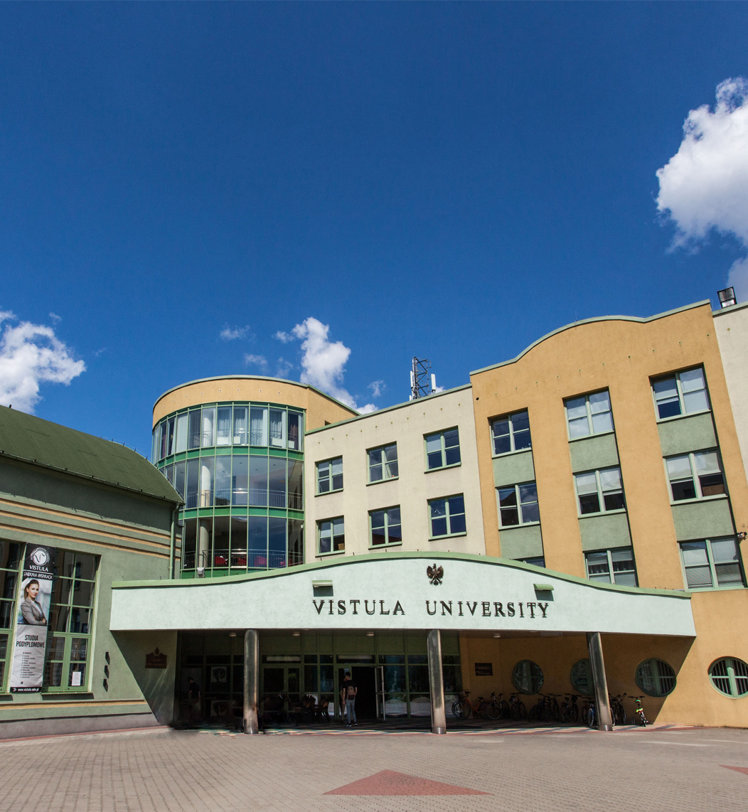

**Doctoral Seminar   
discipline   
Management and Quality Sciences**

**Name of the seminar:**

**Doctoral seminar in the discipline of Management and Quality Studies**

Field of science: Social sciences

Discipline: Management and Quality Studies.

Form of study: Hybrid

Classes will be held every two weeks of each month in accordance with the Vistula Academic Calendar.

Number of semesters: 6

Language: English.

**Head of the Study Programme:**

Prof. Shahriyar Mukhtarov (PhD) – Professor of the Faculty of Business and International Relations, Vistula University.

email address: s.mukhtarov@vistula.edu.pl

phone no.: [+48 22 457 23](tel:+48%2022%2045%2072%20401) 69

**Contact details:**

Postgraduate Studies and Training Center,Vistula University.

email address: [phd@vistula.edu.pl](mailto:phd@vistula.edu.pl)

phone no.:[+48 22 457 23 63](tel:+48%2022%2045%2072%20401)

**Purpose of the Seminar**

Our 6-semester Doctoral Seminar is addressed to graduates of Master's degree programmes (regardless of the completed field of study) who wish to obtain a doctoral degree in the discipline of Management and Quality Studies.

**The aim of the Seminar** is to prepare its participants for independent research work and to provide scientific supervision during the preparation of a doctoral dissertation.

Seminar participants will have the opportunity to:

* Become familiar with the methodology of scientific work as well as the methodology of preparing scientific texts, including doctoral dissertations.
* Acquire theoretical knowledge and practical skills necessary to plan and conduct scientific research, in particular to formulate research questions and hypotheses and apply research methods and techniques.
* Develop skills in the field of working with scientific literature, obtaining and processing data, conducting scientific research, developing and documenting scientific texts.
* Developing the concept and writing a doctoral dissertation under scientific supervision.

**The advantages of the Doctoral Seminar** offered by Vistula University include:

* Participation in classes aimed at improving scientific skills necessary to prepare a doctoral dissertation.
* Individual consultations with scientific supervisors enabling students to develop a concept and then write a doctoral dissertation.
* Facilitating publication of a scientific article, which is a necessary condition for obtaining a doctoral degree.
* Acquire learning outcomes corresponding to level 8 of the Polish Qualifications Framework.
* Possibility to participate in the life of Vistula University scientific community.

The seminar is intended to help all candidates who wish to involve in scientific work and independently acquire knowledge necessary for the preparation of a research project leading to obtaining a doctoral degree in the discipline of Management and Quality Studies.

Our program focuses on issues related to proper formulation of research questions and hypotheses/theses, as well as to adapting appropriate research methods to the selected research questions.

Practical exercises will allow you to acquire the skills necessary to plan and implement your own research project.

**Framework program of the Doctoral Seminar**

* Legal and ethical bases of research in the social sciences (8th level of Qualifications framework)
* Copyright and intellectual property protection (8th level of Qualifications framework)
* Research Methods in Management
* Advanced Topics in Management I
* Quantitative research methods
* Qualitative research methods
* Trends in the Development of Modern Civilization (8th level of Qualifications framework)
* Theoretical foundations and paradigms of science (8th level of Qualifications framework)
* Statistical methods in the social sciences
* Advanced Topics in Management II
* Techniques for writing and publishing scientific articles
* Contemporary technologies in Management
* Doctoral seminars
* Individual consultations with scientific supervisors
* Applied Econometrics: Time-Series Data Analysis
* Contemporary Major Management Issues
* Introduction to academic teaching
* Data Science

**Framework program of 6-semester doctoral seminars at Vistula University in Warsaw in the field of social sciences, discipline of** **Management and Quality Studies in the academic year 2024 / 2025.**

*Classes will be held every two weeks of each month in accordance with the Vistula Academic Calendar.*

|  |  |  |  |
| --- | --- | --- | --- |
| **Nu.** | **Name of the course** | Nu. of hours | |
|  | **Semester 1** |  | |
| 1. | Legal and ethical bases of research activities and higher education | 4 | |
| 2. | Research Methods in Management | 6 | |
| 3. | Copyright and intellectual property protection | 2 | |
| 4. | Advanced Topics in Management I | 18 | |
|  | **Total hours** | **[30]** | |
|  | **Semester 2** |  | |
| 5. | Quantitative research methods | 6 | |
| 6. | Qualitative research methods | 6 | |
| 7. | Statistical methods in the social sciences | 14 | |
| 8. | Trends in the Development of Modern Civilization | 4 | |
|  | **Total hours** | **[30]** | |
|  | **Semester 3** |  | |
| 9. | Advanced Topics in Management II | 16 | |
| 10. | Techniques for writing and publishing scientific articles | 4 | |
| 11. | Contemporary technologies in Management | 6 | |
| 12. | Theoretical foundations and paradigms of science | 4 |
|  | **Total hours** | **[30]** |
|  | **Semester 4** |  |
| 13. | Applied Econometrics: Time-Series Data Analysis | 16 |
| 14. | Introduction to academic teaching | 4 |
| 15. | Contemporary Major Management Issues | 10 |
|  | **Total hours** | **[30]** |
|  | **Semester 5** |  |
| 16. | Doctoral seminar | 8 |
| 17. | Individual consultations | 6 |
| 18. | Data Science | 16 |
|  | **Total hours** | **[30]** |
|  | **Semester 6** |  |
| 19. | Doctoral seminar | 15 |
| 20. | Individual consultations | 15 |
|  | **Total hours** | **[30]** |
|  | **Total number of contact hours** | **180** |

**Fees:**

Aplication fee – **100 Euro one-time**

Tuition fee – **3000 Euro per year**

Payment to the bank account of Vistula University in Warsaw, ul. Stokłosy 3:

Bank: BANK OCHRONY ŚRODOWISKA S.A.

Adres: ul. Żelazna 32, 00-832 Warszawa

Kod Swift: EBOSPLPWXXX

IBAN: PL  
Nr konta: 47 1540 1030 2103 0003 7384 0006