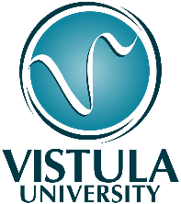
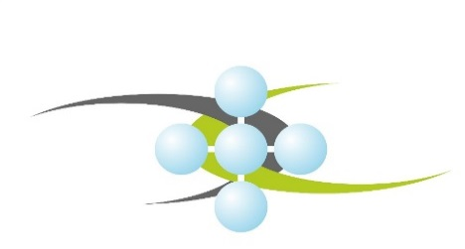

REGISTRATION FORM

International Days on Chemical Safety and Security and Cybersecurity
Warsaw, Vistula University, 9-10 December, 2019

Please return this form before 5TH December, 2019 to: internationaldays@iccss.eu
PARTICIPANT INFORMATION
Country
Position
Organisation
Name and Surname
E-mail
Participation in the Conference activities is guaranteed after receiving a confirmation from Organizers
CONFERENCE INFORMATION: Please indicate which activities you wish to attend
National Conference/Workshop: Cybersecurity as an essential link in industry reliability, 9th December, 2019
International Session on the development of the manual on the management in cybersecurity and reliability in chemical and petrochemical industries, 9th December, 2019
II International Scientific Conference: From the series: Contemporary views on chemical safety and security; The institutional dimension of chemical safety and security, 10th December, 2019
CHEMSS EDU R&D Network International Session on the development of the Education and Training Cybersecurity and Reliability Plan to provide guidance for University educational and Industry training programs

For further information please contact: Ms. Vera Tikhanovich, ICCSS Project Assistant,
e-mail: v.tikhanovich@iccss.eu.
Hereby, I declare, that I read and agree with the Rules of Procedure of the Conference.
I agree to the processing of my personal data provided in the registration form by the Foundation International Centre for Chemical Safety and Security (ICCSS), based in Warsaw at 8/1 Leszno Street, 01-192 Warsaw (National Court Register No. 0000438303) for the purpose of my participation in the event - " International Days on Chemical Safety and Security and Cybersecurity "
I agree to the processing of my personal data provided in the registration form by the Foundation International Centre for Chemical Safety and Security (ICCSS), based in Warsaw at Leszno 8/1, 01-192 Warsaw (KRS No. 0000438303), for the purpose of informing me about future events organized by the Foundation International Centre for Chemical Safety and Security.

